Characterizing Exoplanets Using Kepler Space Telescope Data
By Christine Romano

This project served to investigate how accurately basic characteristics and habitability of exoplanets can be determined using publicly available data from NASA’s Kepler Space Telescope and basic computation tools. Light curve data for the star HD 106315 was analyzed to identify two transiting exoplanets. The depths of their transits, time between their transits, and an application of Kepler’s Third Law of Planetary Motion were used to estimate planetary radii, orbital period, and orbital distance. Based on their calculated sizes, both were classified as “Neptunian” planets, and their orbital periods indicated that neither of them were habitable, as they orbit much too close to their star. The results indicated that transit light curve data can provide significant information about distant exoplanets, and that this information can be independently estimated with simple calculations.

2. Background
2.1 Exoplanets
An exoplanet is any planet beyond our own solar system. Most of them orbit stars of their own, with the exception of planets known as “rogues”, who float through space without a tether to anything else. Exoplanets are incredibly abundant – there are much more of them than even stars in our galaxy – but they are also very difficult to spot (NASA, 2024). By measuring the characteristics of the 6,298 confirmed exoplanets in our galaxy, we can find hints as to what different worlds, and even different kinds of life, are out there.
Exoplanets are classified into four main groups based on their sizes. “Gas giants” are usually the size of Saturn or Jupiter, or sometimes much larger. They include a sub-category called “hot Jupiters”, which are scorching planets made of gas in very close orbit with their star. “Neptunian” or “Neptune-like” planets are similar to Neptune or Uranus, with hydrogen or helium-dominated atmospheres. This also includes a sub-category called “mini-Neptunes”, which are between the size of Earth and Neptune. Lastly, “terrestrial” planets and “super Earths” are planets around the size of Earth that are mostly made out of rock or metal. “Super Earths” are a specific type of “terrestrial” planet that is specifically between the size of Earth and Neptune. Some could possess oceans or atmospheres, or perhaps other signs of habitability (NASA, 2024).
2.2 Life on Exoplanets
It’s important to note that astronomers are not certain of the exact signs of life everywhere in the universe. All humans have to base our speculations on are the signs of life on our planet, in our one-in-a-billion circumstance. However, that is oftentimes enough to make inferences about the rules for life throughout the whole universe. For example, we’ve inferred from the diverse life on our planet that liquid water is likely required for life to begin anywhere, on any planet. This means that any planet with life on it would likely have to be within the perfect distance from their star, where the climate is mild enough to harbor this liquid water without it boiling or freezing. This “ideal” distance is called that star’s habitable zone, and it varies depending on the star’s energy and size (“Life on Exoplanets?,” 2025).
In order for a planet to hold life, the planet must also be terrestrial and large enough to have an atmosphere, and that atmosphere must contain certain elements in the form of gases which help sustain and/or are emitted from the presence of life. Astronomers can look for these gases through transmission spectroscopy, where light from a star passes through its planet’s atmosphere to reach us, and interacts with the compounds in the planet’s atmosphere. This interaction then splits up the light from the star into a spectrum of colors that can be read like a “barcode”, with certain colors indicating the presence of certain elements (NASA, 2025).
2.3 Transit Photometry
There are many methods to identify exoplanets around faraway stars, but one of the most reliable is using what’s called transit light curve data. When a planet orbits a star, there is likely a period in its orbit where it passes in front of that star and blocks a small portion of its light from our telescopes. This creates a slight dip in the visible light, which can be seen and measured when converted to a graph (NASA, 2024). By measuring how much light is blocked, as well as the period of time (in BJD) between successive transits, many of the planet’s characteristics can be calculated.
Telescopes like NASA’s Kepler Space Telescope specialize in observing the flux of millions of stars and searching for behaviors that indicate transiting planets. These findings are then reviewed and published on websites like MAST and the Exoplanet Archive, NASA-funded astronomical data centers. From there, the cleaned-up data is then able to be downloaded and manipulated by anybody.
2.4 Limitations of Transit Detection
However, the transit light method does not work for all cases. For example, there are many cases where a planet’s orbit simply does not pass in front of the star in a way that blocks light from us. Only around 10% of known “hot Jupiters” orbit their stars in a way that they can be detected. Similarly, this method of discovery has a bias towards discovering larger planets (closer to the size of Jupiter) rather than smaller, Earth-like planets, as even the largest examples only block less than 1% of their star’s light. Within the transit light curve method there are also a lot of “false positives”. There are many occurrences, such as multi-star systems and regular stellar variability like starspots, that could cause a star to dim in brightness (Las Cumbres Observatory, n.d.).

3. Research Question & Objective
The research for this project focuses on how accurately one can determine planetary traits from Kepler Space Telescope public data, and whether or not a planet’s habitability can be estimated using those calculations. Kepler data for a star titled HD 106315 (or EPIC 201437844) was used to identify two planets, HD 106315b and c, as well as those planets’ radii, orbital periods, and average distances from their star. By doing this, the planets can also be classified into “gas giant”, “Neptunian”, or “terrestrial” groups. The chances of life on said planets can be determined by factors like their size, orbital distance, and atmosphere’s chemical makeup. Using transit light curve data, only the first two of these factors can be confirmed, but they are oftentimes enough to completely rule out the possibility of life. The calculations were then compared with published NASA data on NASA’s Exoplanet Archive to check for accuracy.

4. Methods & Calculations
4.1 Data
The source of data for this project was NASA’s MAST, a public data center that contains data from telescopes like TESS, the James Webb Space Telescope, and the Kepler Space Telescope. Corrected light curve data (“corrected” meaning unpredictable activity like starspots that affects the star’s brightness have been mostly factored out) is available for public download from any of the Kepler Space Telescope’s 19 K2 campaigns.
The star selected for this project was HD 106315, a star slightly larger than our sun that was observed in the Kepler Space Telescope’s tenth K2 Campaign. HD 106315 is an ideal star for this project, because it holds two large planets whose transits are very easy to see and analyze. It also is a relatively healthy star, meaning that the data won’t be skewed by phenomena like starspots or unpredictable stellar activity.
4.2 Transit Identification
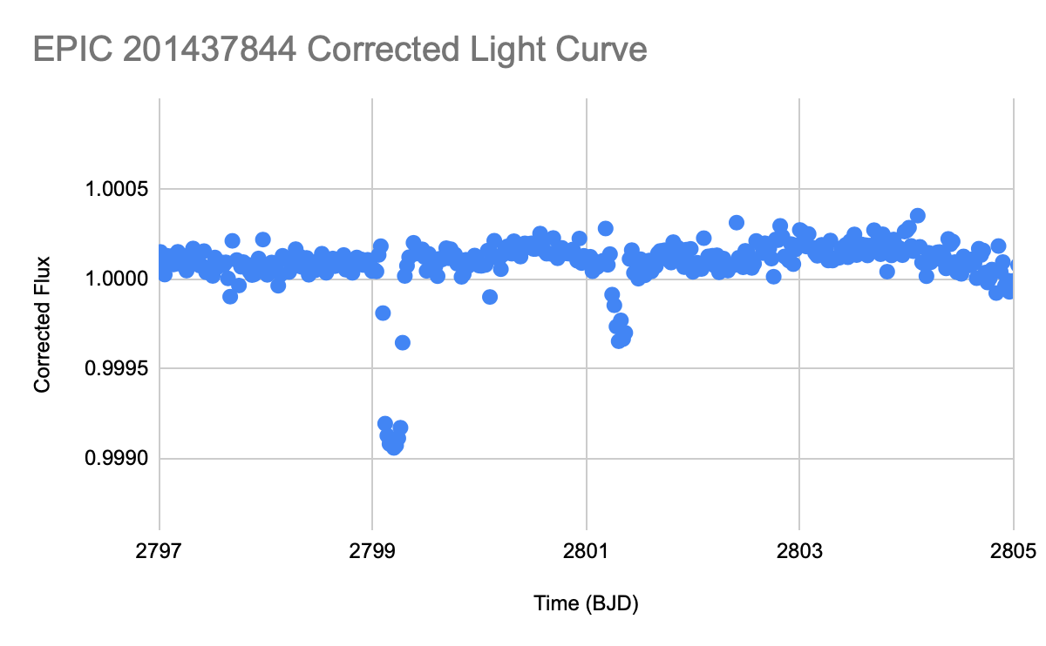
Light curve data from observations of HD 106315 was downloaded from MAST into a .txt file that was then imported into a simple Google Sheets document and converted into a graph showing the star’s overall flux (with 1.000 being its average brightness) over time in BJD (where the difference between each point is the number of days passed). From zooming into this graph, two transits were easily identified, one deeper than the other. The possibility of regular stellar activity was ruled out because of the steep, uniform drops in brightness, which don’t often occur without a planet transiting.
From there, both of the transits were measured for the % of light that they blocked from their star. The first, deeper transit (which we’ll call HD 106315c) blocked about 0.09% of the light from its host star. The second, shallower transit (HD 106315b) blocked about 0.035% of the star’s light.
4.3 Planetary Radius Calculations
Transit depth, ΔF, is proportional to the ratio of the planet’s radius, Rp, to the star’s radius in solar radii, R*, squared (Vanderburg, 2017), meaning:

ΔF = (Rp​/R*​)^2

Rearranging the equation to solve for Rp, it yields:

Rp = R* x (ΔF)^1/2
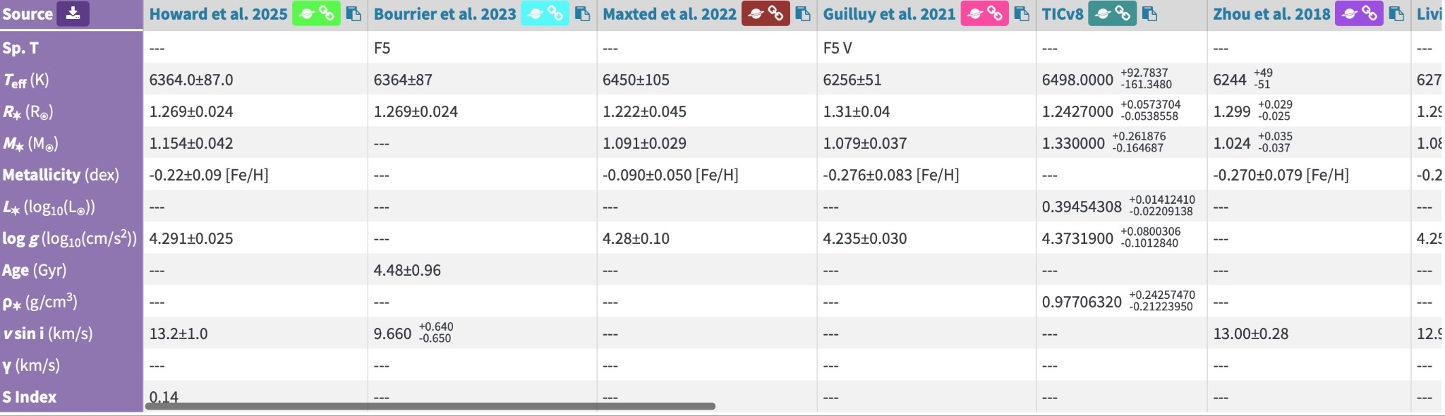
The approximated radius of HD 106315 can be found on NASA’s Exoplanet Archive, where professional researchers upload their values. The most recent peer-reviewed value is 1.269 solar radii, meaning HD 106315 is around 1.269 times the size of our sun. Plugging this, as well as the transit depth (as a decimal), into the equation for each planet gives:
HD 106315b:
Rp = 1.269 x 0.00035^½
Rp = 1.269 x 0.0187
Rp = 0.0237 solar radii
HD 106315c:
Rp = 1.269 x 0.0009^½
Rp = 1.269 x 0.03
Rp = 0.0381 solar radii

Note that this equation yields the radius of each planet in solar radii, as that’s the value that we take the radius of the star in. To convert to Earth radii (the standard for classifying exoplanets), 1 solar radius is about 109.1 Earth radii. This means:

HD 106315b = 0.0237 x 109.1 = 2.5833 Earth radii
HD 106315c = 0.0381 x 109.1 = 4.1529 Earth radii.

4.4 Orbital Period and Distance Calculations
Next, to find the period of each planet’s orbit, the distance between each transit in BJD was taken. BJD stands for Barycentric Julian Date, and it usually references the time from a specified point in cosmic history. The difference between two points in BJD is the time, in days, that has passed between those two events.
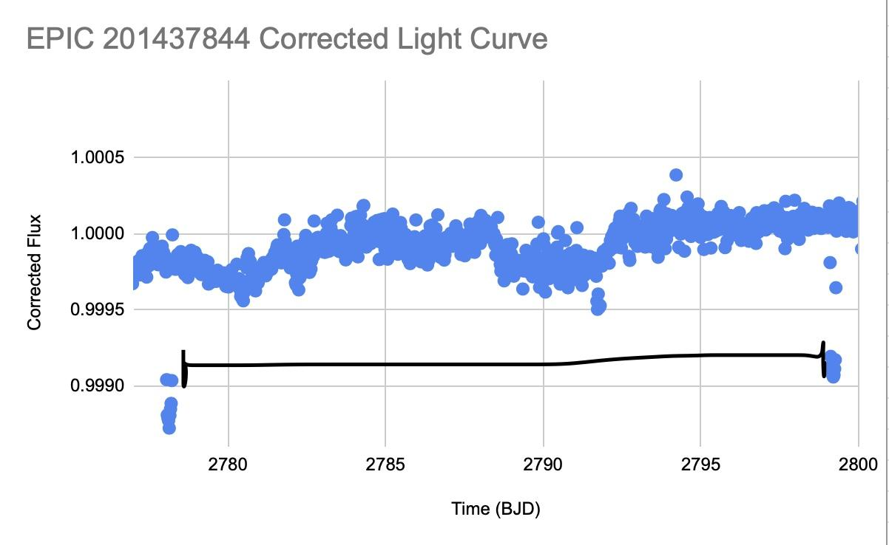
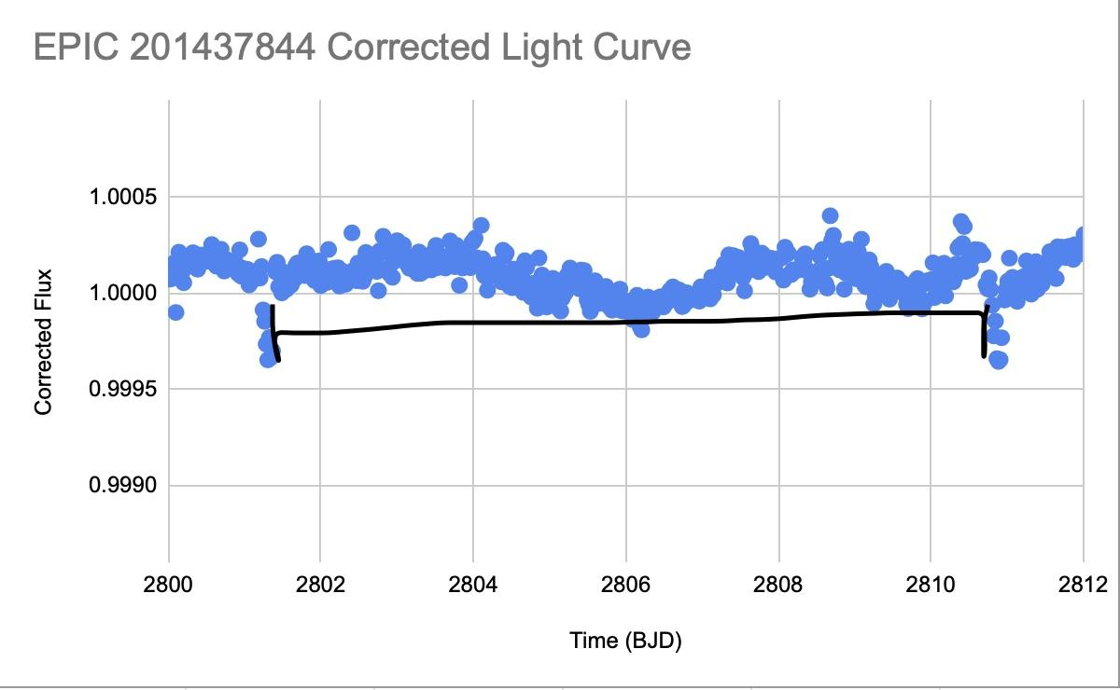
Zooming into two of HD 106315b’s transits, it was observed that the first transit occurred at around BJD 2801.5, and the second at BJD 2811. Subtracting those two yields an orbital period of approximately 9.5 days for the smaller planet.

Next, zooming into two of the larger planet’s transits, it was observed that the first dip occurred at about BJD 2778, and the second at BJD 2799. Subtracting these two yields an orbital period of approximately 21 days.
The last calculation, and the result that could make life a possibility on any of these two exoplanets, was to find the distance at which they are orbiting. To do this, there is a simplified version of Kepler’s Third Law (the square of a planet’s orbital period is directly proportional to the cube of the semi-major axis of its orbit) that yields the orbital distance in AU if the star’s mass is given in solar masses, and the orbital period is given in Earth years. The equation is:
a^3 = P^2 x M*, where:

a is the average distance between the planet and the star in AU (the unit of average distance between the sun and the Earth which is equal to 149,597,870.7 kilometers), P is the period of the planet’s orbit in Earth years, and M* is the mass of the star in solar masses.
This equation was used to calculate the orbital distance for both planets.

HD 106315b:
P = 0.02615 Earth years.
a^3 = 0.02615^2 x 1.154
a^3 = 0.0006838 x 1.154
a^3 = 0.000789
a = 0.0925 AU.
HD 106315c:
P = 0.05766 Earth years.
a^3 = 0.05766^2 x 1.154
a^3 = 0.003325 x 1.154
a^3 = 0.003837
a = 0.1566 AU.

5. Results & Insights
5.1 Classification
From the calculated sizes, the exoplanets can be classified into any of the three identified groups of exoplanets – “gas giants”, “Neptunian”, or “terrestrial”. HD 106315b, the smaller planet, is only twice the radius of Earth, and therefore would be classified as “Neptunian”, more specifically a “mini-Neptune”. It is larger than any terrestrial planet, and therefore is likely a planet made of hot gas with no surface. HD 106315c is the larger planet, at around four times the size of Earth. It would still be classified as “Neptunian”, but it would be referred to as “Neptune-like”, meaning that it is much larger than Earth, and close enough to the size of Neptune to be compared to it.
5.2 Habitability
As previously stated, there are a few near-definite requirements for a planet to hold life. In order to find a hint to life on either of our exoplanets, they would need to be terrestrial planets (though there are some theories that microscopic life could exist in the highest layer of gas planets) that are within the correct distance from their star. Finding the habitable zone of a certain star requires much more data than what is available, so the orbital distances of the planets were compared to the sun’s habitable zone, which would be slightly closer than HD 106315’s.
The sun’s habitable zone is between 0.95 and 1.37 AU (“Life on Exoplanets?”, 2025). HD 106315’s would be slightly farther away, considering that it is a star about 1.2 times the mass and energy of our sun. Both planets fall between 0.09 and 0.16 AU. This means that both of their orbital distances would be much too close to sustain life. It’s likely that they are both hot gas planets hostile to life as we know it.

6. Verification/Validation
The calculated values were compared with the values published by NASA on the Exoplanet Archive. According to NASA, the most precise values for all of our measurements are:

HD 106315b:
Size: 2.44 Earth radii
Orbital period: 9.55 days
Orbital distance: 0.0907 AU
HD 106315c:
Size: 4.35 Earth radii
Orbital period: 21.06 days
Orbital distance: 0.1536 AU.

The close agreement between the calculated results and published values demonstrates how relatively simple analysis of publicly available data can produce estimates comparable to professionally determined calculations. Transit photometry, even when analyzed with basic tools, is an incredibly effective method for estimating fundamental planetary parameters.

7. Conclusion
As previously stated, this project set out to determine how accurately base characteristics of exoplanets can be identified using publicly available telescope data and relatively basic calculations. By analyzing transit light curves of HD 106315, two transiting exoplanets were identified and calculated to be close-orbiting, gaseous “Neptunian” planets that are unlikely to be habitable.
Beyond the specific characteristics of the two planets, this project demonstrates the incredible accessibility of astronomical data. Information collected by a telescope about a star millions of kilometers away can be published publicly and analyzed by anybody with a laptop and knowledge in mathematics. To calculate data so precisely without access to specialized equipment or even an individual telescope proves how universal and available the field of astronomy is. With curiosity, mathematical reasoning, and access to public data, the faraway universe can be studied from virtually anywhere.

